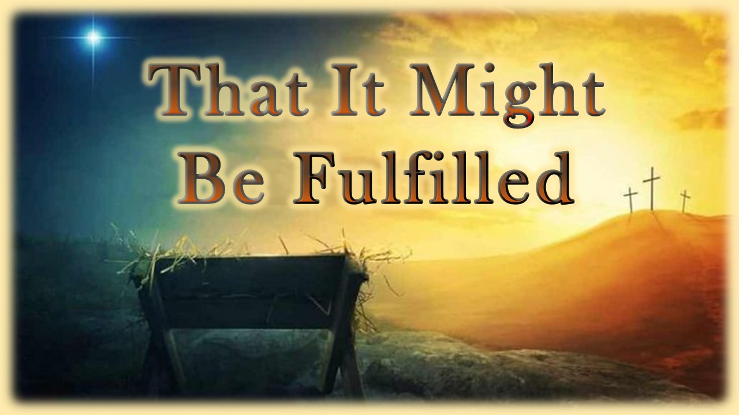  Thank You!  We are glad you joined us today! We pray that you will experience God’s presence as we share the wisdom found in His Word.  To receive text messages from First Baptist about upcoming events  Text the letters FBCD to the number 615-908-2234  Our Service Times:  Sundays: 9 & 10:30 am Worship & Sunday School  Wednesdays: 6:30 pm Bible Study Classes & Small Groups  Contact us for more info: 615-446-4640 or fbcdickson.org  Our Mission:  Following Jesus. Loving Others Like Jesus. Telling the World About Jesus. |  |  | Today’s Sermon Scripture: December 3, 2023  “Now all this took place to fulfill what was spoken by the Lord through the prophet.” - Matthew 1:22  Focal Truth: Jesus Christ birth and life fulfilled all the promised prophesies of the Old Testament.  Observations:  - The birth and life of Jesus Christ was predetermined to be fulfilled. – Matt. 1:22  - The birth and life of Jesus Christ was promised to be fulfilled. – Matt. 1:21  - The birth and life of Jesus Christ was predicted to be fulfilled. – Matt. 1:21  - The birth and life of Jesus Christ was perfectly fulfilled. – Matt. 1:21  Things to Remember and Do:  - God keeps all His promises in Jesus Christ the Lord!  - What is written in God’s word comes to life in Jesus Christ the Lord!  - Put your trust for everything in life and beyond in Jesus Christ the promised One!  - Worship and serve Lord Jesus Christ the promised Savior and Lord of all!
  First Baptist Church
  of Dickson
  Order of Worship
  Advent: Pastor Ken Metcalf & family
  FBC Preschool Choir: led by: Dorothy Hatcher/Michelle Bellar
  Singing Together: “God So Loved”
  “Hark the Herald w/King of Heaven”
  Welcome & Prayer
  Singing Together: “Emmanuel”
  “Crown Him”
  Offertory Prayer: Pastor Jeff Clark
  Sharing in Song: “He Shall Reign Forevermore”
  Sermon: Pastor Mike Miller – That It Might Be Fulfilled
  Invitation: “Turn Your Eyes”
  Closing Song: “Go Tell It on the Mountain”
  

