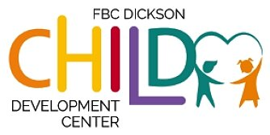

First Baptist Child Development Center is looking to hire (4) positions for temporary summer help for our children attending Kindergarten in the fall. Candidates must be at least 18 years of age with a high school diploma or equivalent, love children, have a hard work ethic and are dependable. The hours are 7:00am - 5:00pm 2-3 days per week starting May 30, 2023. Our center is closed July 3-8, 2023. Pay is based on experience.

Duties:
*Leading and supervising recreational and educational activities each day
*Maintain all state guidelines and regulations for childcare.
*Ensure children's safety each day
Requirements:
*High School Diploma or Equivalent
*Have a passion and love for children
*CPR/First Aid certified (online class provided)
*Complete (3) childcare certifications
*Pass a national background check
*Energetic, fun and positive attitude
*Reliable and punctual
*Organization and communication skills

If you are interested, please contact Kim Moultrie at (615) 446-5225 ext. 118 or by email at kmoultrie@fbcdickson.org
Great opportunity for High School Graduates, College Students, Retirees!

