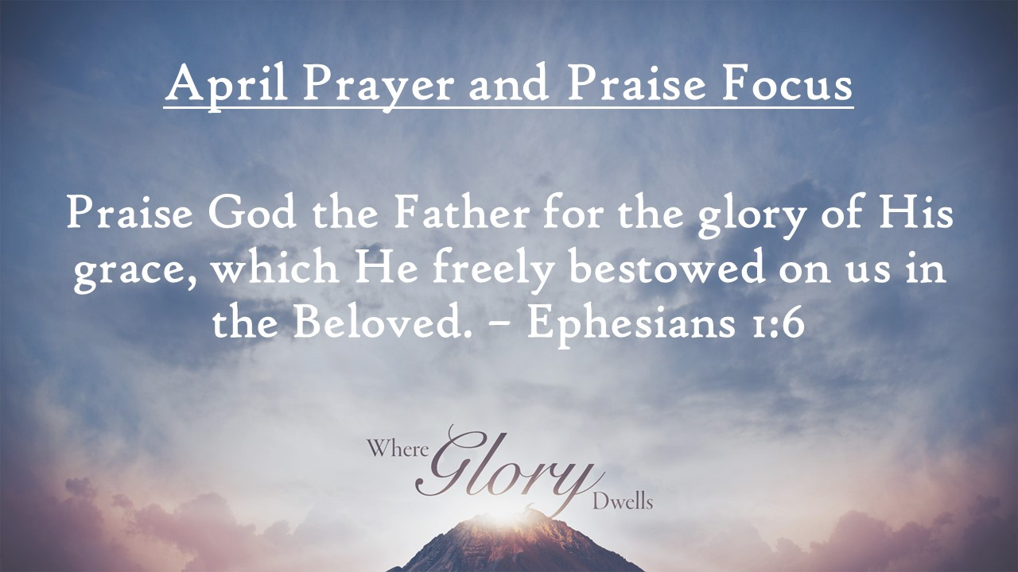
First Baptist News & Info |  |  |  | April 19, 2024
Prayer Focus for month:
Ephesians 1:6

Meditation Moment: |  | How great is the love the Christian receives from both God the Father and God the Son. The incarnation is quite unimaginable as God the Father watches his beloved Son suffer so that people might be forgiven of sin. The love of God is on display as the Son empties himself by taking on human flesh. The ultimate height of salvation is that God loves humanity as he loves the Son, because they are united with the beloved. The Christian is called beloved, revealing an intimacy surpassing anything imaginable. (Dr. Martyn Lloyd-Jones)

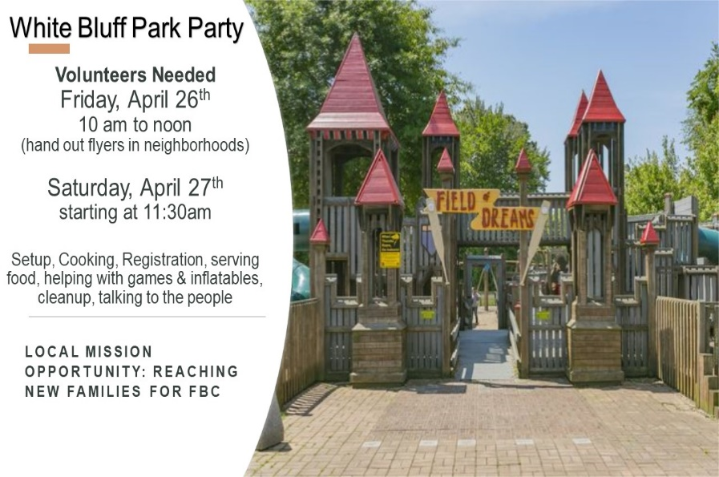
 |  | April 19, 2024
Invite a friend…Hitting the Bases! This is the final week of fun and activities. Events begin at 6 pm. This week is a 90 foot inflatable obstacle course with hamburgers/hot dogs dinner!  Attendance/Offerings: April 14, 2024  - Sunday Morning Worship – 521  - Sunday School – 530  - Online Worship – 61  - Tues/Thurs Bible Studies- 37  - Wednesday Bible Studies – 307  - Tithes & Offering – Budget: $33,365.00 Sacred Trust: $330.00  Regular Worship at 9 AM and 10:30 AM in the Sanctuary. The 10:30 AM service will be livestreamed via Facebook and YouTube. Sunday School classes are available for all ages at 8:00 AM (adults only), 9:00 AM (all ages), and 10:30 AM (adults and Preschool only)  Register for Girdiron Men’s Conference: June 14-15 in Huntsville, AL. Cost starts at $200.00. Registration and information is on the men’s bulletin board and the church website. If you have questions please contact Pastor Todd Vermilyea. |  | Upcoming Activities  - April 22nd at 4 pm - Senior Adult Game Night  - April 25th at 1pm – Widow’s Luncheon Fellowship  - April 26th – 10 am – noon – White Bluff Neighborhood Canvasing for Park Party  - April 27th – 1pm to 3 pm - White Bluff Park Party Outreach (signup on front bulletin board)  - May 1st – 6:30 pm – Kid’s JAM Spring Musical  - May 5th – Senior Graduation Recognition  - May 5th at 11:45 am - White Rose Luncheon
Mid-week Activities: Wednesday, April 24th
- Youth Choir – 5:00 pm in the choir room
- Kids JAM - Children’s Choir – 5:15 pm in the B hallway (Upcoming concert: May 1st at 6:30pm in the sanctuary – THY WORD)
- Fellowship Hall: Pastor’s Bible Study – 6:30pm
- DiscipleLife Classes: 6:30pm, C-Hallway, Guest Central, Youth Building
- Children’s Activities: Children’s Activities: 6:30 pm childcare for birth through ages 3, Mission Friends, RA/GA classes (Pastor Ken Metcalf, Children’s Minister)
- Student Activities: 6:00 pm Hitting the Bases (Pastor Tim Hopper, Student Minister)
- Adult Choir: 6:30 pm (Pastor Jeff Clark)

