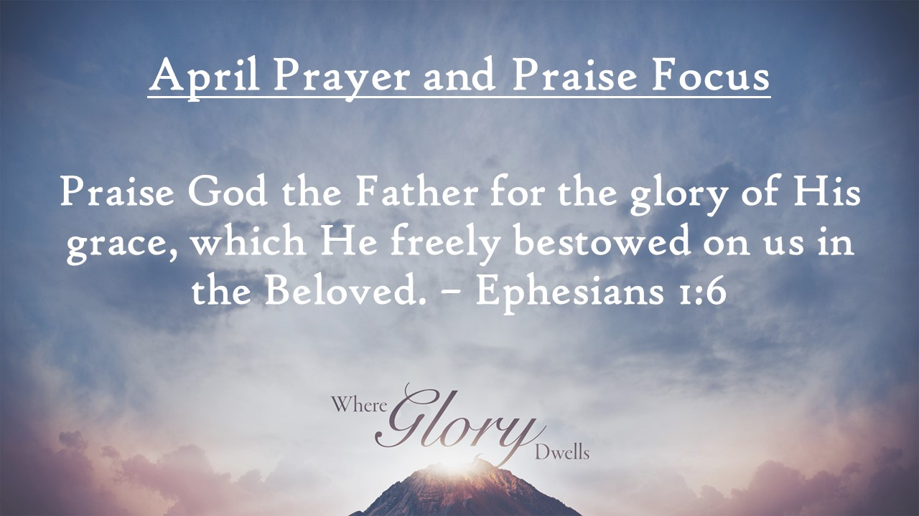
First Baptist News & Info |  |  |  | April 12, 2024
Prayer Focus for month:
Ephesians 1:6

Meditation Moment: |  | How do you praise God’s Glory?  - Give thanks  - Sing  - Seek His strength and His counsel  - Celebrate  - Pray  - Tell others about His love

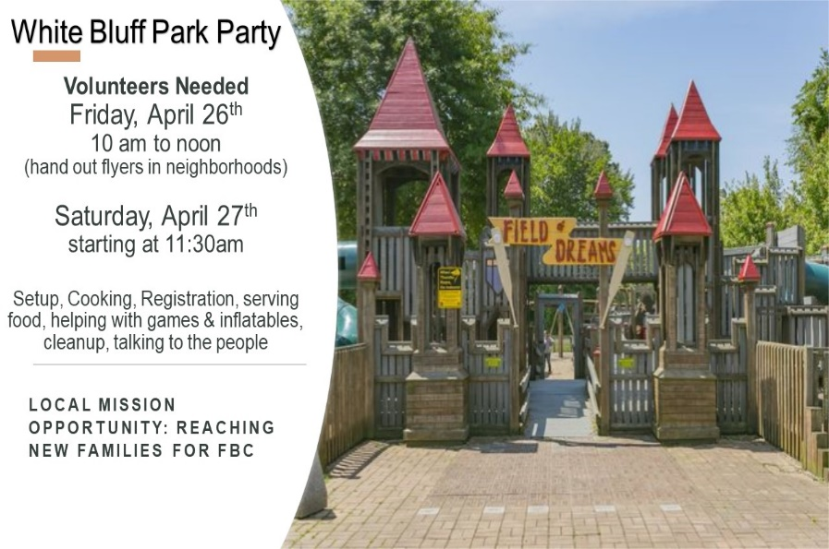
 |  | April 12, 2024
Invite a friend…Hitting the Bases will be each week in April. Activities begin at 6 pm on the softball field. This week (if it doesn’t rain) is Yard Games and Pizza!  Attendance/Offerings: April 7, 2024  - Sunday Morning Worship – 480  - Sunday School – 550  - Online Worship – 49  - Tues/Thurs Bible Studies- 26  - Wednesday Bible Studies – 345  - Tithes & Offering – Budget: $47,299.39.00  Regular Worship begins at 9 AM and 10:30 AM in the Sanctuary. The 10:30 AM service will be livestreamed via Facebook and YouTube. Sunday School classes are available for all ages at 8:00 AM (adults only), 9:00 AM (all ages), and 10:30 AM (adults and Preschool only)  Register for Girdiron Men’s Conference: June 14-15 in Huntsville, AL. Cost starts at $200.00. Registration and information is on the men’s bulletin board and the church website. If you have questions please contact Pastor Todd Vermilyea |  | Upcoming Activities  - April 22nd at 4 pm - Senior Adult Game Night  - April 25th at 1pm – Widow’s Luncheon Fellowship  - April 26th – 10 am – noon – White Bluff Neighborhood Canvasing for Park Party  - April 27th – 1pm to 3 pm - White Bluff Park Party Outreach (signup on front bulletin board)  - May 1st – 6:30 pm – Kid’s JAM Spring Musical  - May 5th – Senior Graduation Recognition  - May 5th at 11:45 am - White Rose Luncheon
Mid-week Activities: Wednesday, April 17th
- Youth Choir – 5:00 pm in the choir room
- Kids JAM - Children’s Choir – 5:15 pm in the B hallway (Upcoming concert: May 1st at 6:30pm in the sanctuary)
- Fellowship Hall: Pastor’s Bible Study – 6:30pm
- DiscipleLife Classes: 6:30pm, C-Hallway, Guest Central, Youth Building
- Children’s Activities: Children’s Activities: 6:30 pm childcare for birth through ages 3, Mission Friends, RA/GA classes (Pastor Ken Metcalf, Children’s Minister)
- Student Activities: 6:30 pm in the Conference Center (Pastor Tim Hopper, Student Minister)
- Adult Choir: 6:30 pm (Pastor Jeff Clark)

