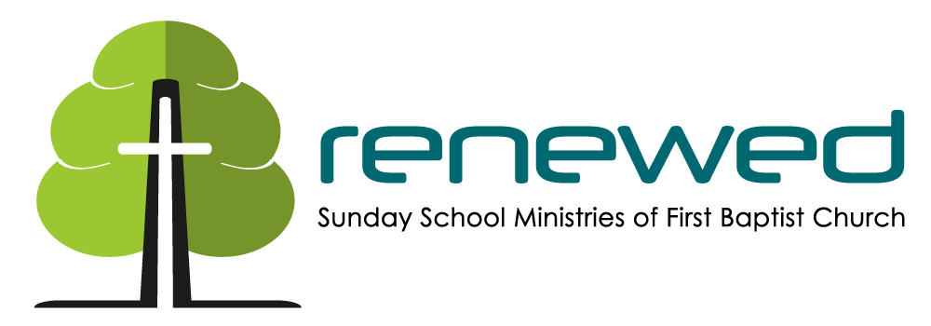

FBC Dickson Guidelines for Reopening Adult SS:
- Follow Social distancing guidelines when possible
- Clean commonly touched surfaces when you leave.
  - Door handles
  - Tables
  - Podium/lectern/ Music Stands
  - Cabinet handles
  - Microphones
  - Dry erase Markers
- Masks Optional (Recommended)
- Refrain from passing objects around
  - Teaching aids
  - Benevolence collections
  - Etc.
- For now please do not have food, coffee, etc. in the rooms
- 9:30am classes as much as possible please park in the back of the building. We ask you to not enter the building through the main foyer of the church while 9am worship attendees are entering. So please enter through fellowship hall entrance or through the gym or conference center entrance if your class is in Y-Building.
- 9:30am classes will be released on a staggered schedule(See Below) and will be asked to sanitize (per guidelines above). They will all exit down B-Hallway and enter worship Center at side entrance (near kitchen) for worship @11pm
- 9am worship will exit (weather permitting) out front entrance of church to go to 10:30am SS class
  - C-Hallway classes will walk down sidewalk past CDC entrance and use sidewalk between Y Building and Main building to enter B Hallway and continue to C Hallway classrooms
  - Y Building classes (Y classrooms, Gym, and Youth room) will use sidewalk between B hallway and Y building and enter through:
    - Conference Center entrance for Conference center classes
    - Side entrance for 3 Y classroom classes
    - Gym entrance at breezeway for Gym or youth room classes
  - In case of inclement weather, 9am worship will be dismissed to go down A Hallway:
    - C- Hallway classes will go through playground breezeway and enter C Hallway
    - Y Building classes will also go through playground breezeway into B/C hallway intersection and turn down B Hallway to go to Gym/Youth room/ and Y Classrooms.

SS 9:30am
Release at 10:15
C-107-109- Lewis Bratton
C-111-113- Joe Claggett
C110-112- Edwin Davis
Gym- Todd

Release at 10:20
Choir Room- Keith Nash
C101-105- Frank Whitaker
C-102-104- Louise Myatt
C-106: Beth Bergren

Release at 10:25
Youth Room- Barden/Wales/Stefan*
Y-105- Roy Williams
Conference Center- Mark Brannan

CLASSES:
8am
C-110-112- Roy Smith-

SS 9:30am
C-111-113 Joe Claggett
C107-109- Lewis Bratton
C110-112- Edwin Davis
C-101-105- Frank Whitaker
C-102-104- Louise Myatt
C-106: Beth Bergren
Gym- Todd
Conference Center- Mark Brannan
Youth Room- Barden/Wales/Stefan*
Y-106- Roy Williams
Choir Room- Keith Nash

SS 10:30am
C-107-111- Richard Moore
C110-112- Angie Richardson
C-102-104- Skeet Owen
Gym- Vacant (May be used for overflow at 11am service)
Conference Center- Odds and Ends
Youth Room- Ryan Wicker Couples- (The Gospel Project)
Y-105- Faith Riders
C-106- Pat McDaniel-
Y-106- Kerry Pharr
Y-110- Vacant
Choir Room- Vacant
B109- Special Friends

