Dear Church Family,
Proclaim confidently, just as David did in the Psalm, that you will consistently follow God and be obedient to His will. In all ways be faithful to the Lord.
“My steps have held to Your paths; my feet have not slipped.” (Psalm 17:5)
Church events are on the website, the announcement slides, or they are highlighted in the weekly Sunday announcement video.
- Find details about Rising 6th grader parent/student info luncheon, VBS Volunteer/Participant Registration, & other news & updates.
- South Asia Trekking Mission Trip Informational Meeting – Rm C101 @ 11:45am, May 15th (lunch provided)
- CDL bus drivers needed for trips. Contact Kristal Turpin kturpin@fbcdickson.org if interested.
- Take note of the invitation to join our new online https://onrealm.org/FirstBaptistChurchDickson church directory. Use the link or scan one of the QR codes you’ll find around the building this Sunday. Create your own log-in and password to be a part of online giving and class information.
Church Schedule: Sunday Morning: Sermon: The Light of the Gospel & the Glory of Christ
Regular Worship: at 9 and 10:30 AM in the Sanctuary; observance of The Lord’s Supper following the message. The 10:30 AM service will be livestreamed via Facebook and YouTube. We will have Senior Graduate Recognition at the beginning of this service followed by a reception in the foyer at 11:45 AM.
Sunday School classes are available for all ages: at 8:00 AM (adults only), 9:00 AM (all ages), and 10:30 AM (for adults and Preschool). Find a place in small group and connect to great opportunities.
Wednesday Evening Schedule: May 18, 2022
- Bible studies for all ages
  - Bible Study for all ages in the sanctuary at 6:30 pm
  - Men’s and Women’s classes - Hallway C begin at 6:30 pm
- Children’s Activities: 6:30 pm Mission Friends, RA’s & GA’s; childcare for birth through ages 3.
Pastor Ken Metcalf, Children’s Minister.
- Student Activities: 6:30 pm Bible Study in the Conference Center. Pastor Tim Hopper, Student Minister.
Attendance for the week of May 8, 2022.
- Sunday – 5.8.2022
  - Worship- 475 in person and 28 households online – total 503+
  - Sunday School – 450
- Tuesday Bible Study Classes- 11 (Men’s Bible Study only)
- Wednesday – 5.11.2022
- Nursing Home Service – 17 (led by: Pastor ken Metcalf)
- Wednesday Night: 231 in person 19 households online – total 250+
Offerings: 5.8.2022
- Total offerings received - $ 39,698.01
- Sacred Trust: $660.00 $ MTD - $ 28,412.25

Blessings to you and yours! Thank you for your faithfulness. First Baptist Staff, Deacons & Committees

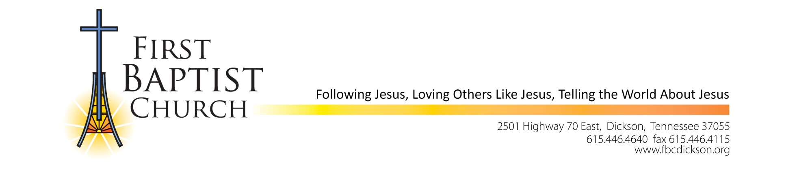

FBCD Announcement
May 11, 2022

The Personnel Committee with input from Pastor Mike make the following announcement.

- Effective May 6, 2022, Henry Hamm has been hired as the church pianist. Henry and his family joined the church over 14 years ago and he has participated in the music ministry for over 10 years. Henry began playing the piano at age 10; he was classically trained. He has almost 30 years experience playing for church choirs, ensembles, weddings and other church events.
Please welcome him to this position.

- Effective May 1, 2022, Lori Snow was named Director of Media, Communications, Women’s Ministries and Assistant to the Senior Pastor. Lori has been a member at FBCD for 9 years and a Ministry Assistant for six years. In this position she will continue to oversee and coordinate all media and communications for the church. She will take on the directorship of Women’s ministries for our church and serve as Assistant to the Senior Pastor.

Please congratulate them and thank both of them for their dedication to our church and service to Jesus Christ.

High School:
Sarah Ahlheit – daughter of Stephen & Susan Ahlheit
Raegan Andrews – daughter of Mike & Shelley Andrews
Erin Barrett – daughter of Jody & Holly Barrett
Reid Baggett – son of Aaron & Amy Baggett/grandson of Ken & Darlene George
Hailey Binkley – daughter of Kevin Binkley & Jacqueline Miller
Ian Boswell – son of Todd & Christina Boswell
Daaron Burney – son of Adam & Amy Burney
Brock Chitwood – son of Patrick & Tashina Chitwood/great-grandson of Gordon & Marjorie Smith
Scarlett Cook – daughter of John Cook
Nicholas Gates – son of Jonathan Gates
Alex Haggard – son of Steven & Amanda Haggard
Luke Hendriks – son of Doug & Nikki Hendriks
Samuel Markem – son of Brian & Lora Markem
David Martinez – son of Valentin & Ruth Martinez
Ryan Metcalf – son of Ken & Robin Metcalf
Kamren Nguyen – son of Kevin & Tammy Nguyen
Shelby Tucker – daughter of Ryan & Susan Tucker

College:
Brook Deal – daughter of Rodney & Shannon Deal
Joe Jackson – son of Jerry & June Jackson
Skylar Lambright – daughter of Stephen & Sherree Lambright
Jenna Veasman – daughter of Brian & Dana Veasman
Abigail Warren – daughter of John & Lori Warren

