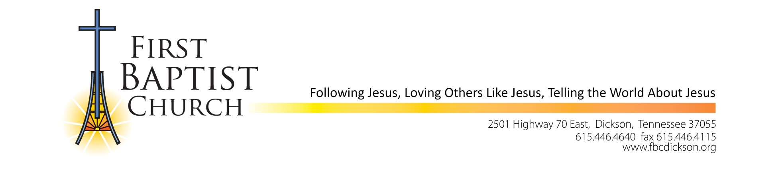

March 15, 2023

Dear Church Family,

The Personnel Committee continues the process of identifying the next candidate for the Associate Pastor of Worship and Music at our church. On behalf of the committee and Pastor Mike, let me update you on our progress and plans to date.

* Scott Shepherd, our current interim, will complete his last worship service on Sunday, April 2, 2023.
* The Personnel Committee has scheduled meetings and interviews with a potential full time candidate in March; however, the process is not complete. The committee recommends that the church call an interim to fill the time between Scott Shepherd’s departure and the call of a full time pastor.
* The Personnel Committee recommends that the church call Dave Briley as interim Associate Pastor of Worship and Music effective May 28, 2023. Dave has visited our church, met the staff and led a choir rehearsal on February 22, 2023. The Personnel Committee interviewed him on March 14, 2023, and unanimously voted to recommend him as interim. Pastor Mike is supportive of this recommendation.
* The church has secured Dave Briley to lead worship for the Easter week services and to lead choir rehearsals and worship services during April. Dave Briley is willing to serve as interim in our church; however, he is not available during May due to a prior commitment.
* The church will receive a packet of information that includes Dave Briley’s résumé, testimony and details of the call. There will be opportunities scheduled for the church to meet Dave and get to know him.
* The vote on the call of Dave Briley will be on Sunday, April 23, 2023, in both the 9:00 AM and 10:30 AM services.

If you have questions or need additional information, please contact Arrita Summers by email at [arrita.summers@yahoo.com](mailto:arrita.summers@yahoo.com).

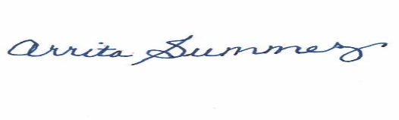

Personnel Committee, Chair