Who’s Your One Implementation Team
- Welcome/Prayer

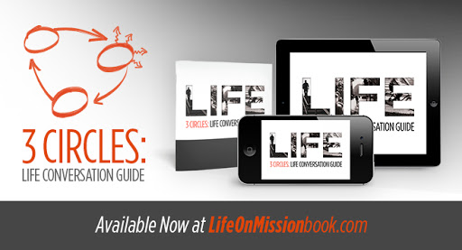
- 3 Circles intro (booklet/App)

- Prayer Card – (can be prayed over daily by a class)
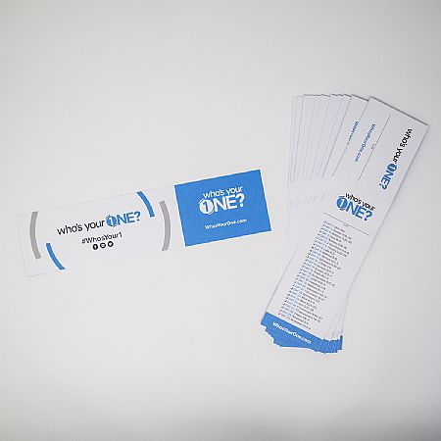
**small business cards for names will be handed out in Sunday school classes **

- Ryan - Sunday School Reach
Each class has a representative contact giving understanding of what Who’s Your One is, supplies (prayer guides, links, 3 circles, etc. –teaching to use the site resources) whosyourone.com

