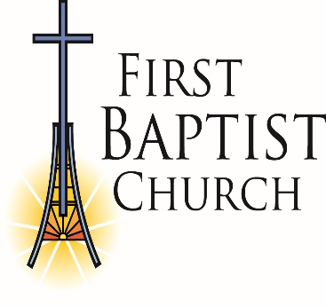 First Baptist Church
Application for Employment

Name ________________________________________________________________________
Last First Middle
Address _______________________________________________________________________
Street City State Zip
Telephone __________________________________ _________________________________
Area code and number Cell Number
Email Address________________________________________________________________

Position Desired ________________________________________________________________

Date available to begin work_____________________________________________________

Educational Background (List Diplomas, Degrees and Certifications)
Title | School and City | Dates

Educational Background (List all training programs attended, i.e., workshops, conferences and courses.)
Title | Place | Dates

Employment History (List most recent job first)
Place | Position | Dates | Reason for leaving

Other Work Experiences
__________________________________________________________________________________________________________________________________________________________________________________________________________________________________________

References (List three references including employers and personal references)

Name and Title | Phone Number | Time Known

Have you ever been arrested or convicted for a felony including any involving suspended sentences? Yes _______________ No _______________

Have you ever been reported for child abuse or neglect? Yes ___________ No _________

Is “Yes” for either, please explain. Provide details and dates.
__________________________________________________________________________________________________________________________________________________________________________________________________________________________________________
TCA 14-10-129 states that “each person applying to work with children as a paid employee…shall complete an application form prescribed or approved by the Department of Human Services…It is unlawful for any person to falsify any information. Knowingly failing to disclose required information shall be deemed to be falsified to the same extent as providing false information.”

By signing this form, I am affirming that the above statements I have made are true and factual to the best of my knowledge. In addition, I am granting permission for all persons, organizations, or agencies listed above to be contacted for the expresses purpose of pre-employment screening.

I further acknowledge that should I be a candidate selected for employment I agree to adhere to the church policy on “Marriage and Sexuality” as well as sign the “Code of Ethics and Rules of Conduct”. I will be required to sign forms indicating that I agree to support these church policies.

Name (Signature): ________________________________________________

Print Name: ____________________________________________

Date:_______________________________

Please attach your résumé and completed application to: Lori Snow, First Baptist Church - Dickson, 2501 Highway 70 East, Dickson, TN 37055 or email to lsnow@fbcdickson.org.

