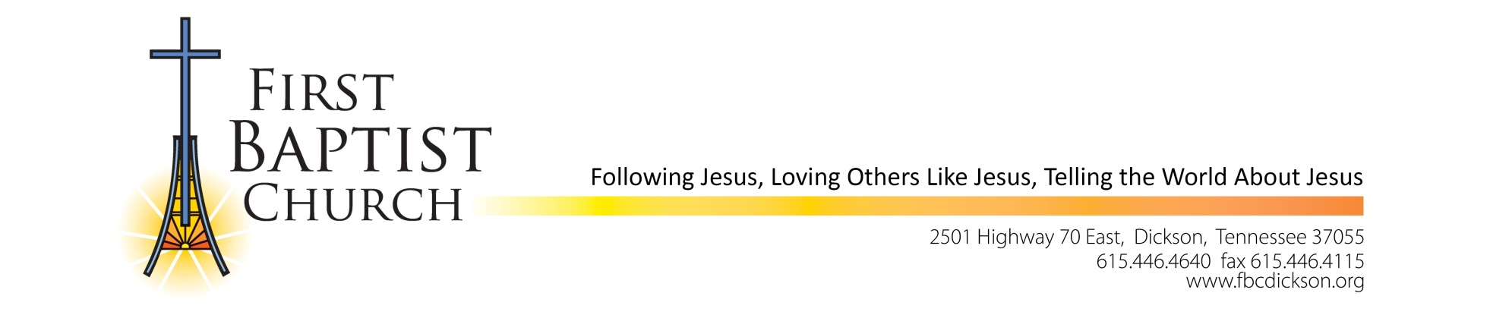

**POSITION ANNOUNCEMENT**

Associate Pastor of Worship and Music

First Baptist Church Dickson (FBCD) is accepting applications for the full-time position of Associate Pastor of Worship and Music in Dickson, Tennessee. The church is located approximately 40 miles west of Nashville, Tennessee and considers Dickson as a western suburb of Nashville. It offers both the city and country experience. Our church is committed to “Following Jesus, Loving others like Jesus, and Telling the world about Jesus”. The church is multigenerational and ministers to seniors as well as young families. The student and children ministries are vital to our church. Worship and music are a critical part of Sunday mornings that help create the spirit of worship.

**MINIMUM REQUIREMENTS**

* Confessed/Professed doctrine consistent with the Southern Baptist Faith and Message.
* (Preferred) Advance Music Degree.
* (Preferred) Ordained in a Southern Baptist Church.
* (Preferred) Minimum of seven (7) years of experience leading and coordinating the music program in a church with active membership of 500+.
* Familiarity with current church music methods and trends.

**SKILLS**

* Must possess communication and leadership skills necessary to direct the congregation and worship teams to use their voices and instruments to worship God.
* Must lead worship in all regularly scheduled worship services.
* Must recruit, train and organize all instrumental, vocal and technical worship team members.
* Must oversee all areas of the worship ministry at FBCD including vocals, band, orchestra, sound, multi-media, and adult, student and children’s choirs.
* Must participate in all aspects of congregational life including, but not limited to small groups, fellowship events, service projects, and leadership training.

**GENERAL DUTIES:** The Associate Pastor of Worship and Music (APWM) is responsible for planning and directing worship while working with the Senior Pastor to ensure that worship incorporates the overall direction of the church. This position is directly responsible for planning, organizing, conducting and evaluating a comprehensive music program. The APWM will serve as spiritual leader to those involved with the musical teams and congregation.

**SALARY:** Commensurate with other churches of like size and responsibilities

**APPLICATION SUBMISSION AND REVIEW:** Please submit completed application and résumé to Lori Snow at [lsnow@fbcdickson.org](mailto:lsnow@fbcdickson.org). Review of résumés with completed employment application will begin immediately and continue until the position is filled.