Sunday: Pray for the church as we gather to worship/Pray for Revival in our church and churches and around the world-
- Worship may not look like it normally does, but we still worship.
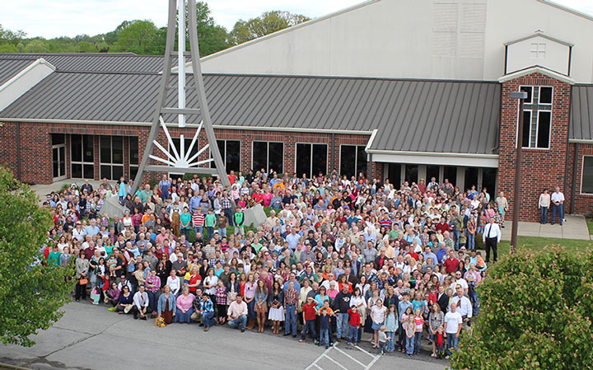
- For children to continue to come to Sunday School even if it is by Zoom.
- For Sunday School teachers as they prepare and deliver quality spiritual classes by Facebook, Skype, Zoom, or text/phone calls.
- Pray that churches will repent and come back to their First Love.

Monday: Pray for Guatemala –
- 5/5/20 update –Many people in Guatemala, in normal times, just live from day to day. They don’t need a sermon to truly understand what praying for “our daily bread” means. These days some families are genuinely suffering from hunger because no money is being made by the vast majority of people.
- The e3Evangelism leadership team who are seeking ways to minister in unknown times.
- The e3Evangelism team is seeking to find ways to keep their ministry functioning when the structure is built on using volunteers as a key element to provide the leg-power to the operation of the ministries.
- Church leaders are seeking to reach out to new areas of need even now.
- Our Youth will have the opportunity to work with the people of Guatemala.

Tuesday: Pray for Who’s Your One/Pray for many in the world to be saved through a Global Awakening- Go to https://whosyourone.com/ to pray for those individuals that church members have identified who need the Gospel. Even during this time of change, we can still share the Good News with others.
- Johnny Hunt continues to use every means to encourage all of us to reach out to “Our One”.
- For everyone to think of those they know and identify their family, friends, and neighbors to be “Their One”.
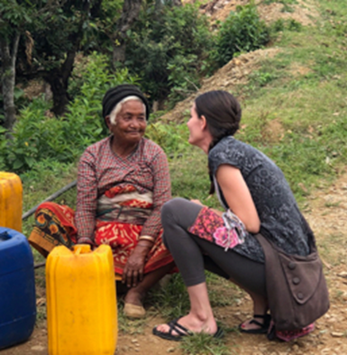
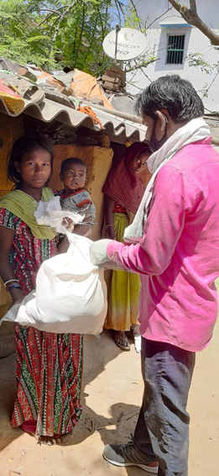
Wednesday: Pray for South Asia –
- 5/5/20 update- Last week we were able to provide food for about 500 families and shared the gospel with many/most of them. Additionally, we pushed hard on telephone-evangelism and saw about two hundred people come to faith. (Jarrod)
- Almost everyone in many counties are under stay-at-home orders. No one can go out to work or to go to the story or the doctor. Many are day laborers, “simply put, if they can’t work today, they can’t eat today.” Churches who suffer from lack of adequate food and health supplies are going out to distribute food to the needy and care for the needy.
- Church leaders seeking to find ways for their churches to worship, fellowship, study, and reach out in these difficult times.
- Pray for missionaries who are being identified as foreigners and all foreigners are identified as the people who brought this unknown sickness to South Asia.

Thursday: Pray for California-
- New churches were in process of formation when Corvid-19 hit. Leaders, believers, and seekers still want to meet and form the new churches.
- The Inland Empire Baptist Association, led by Deryl Lackey and Claudio Medina, strives to meet the needs of churches, members, seekers, and those in need.
- Pray that the Lord will grant Deryl and Claudio innovative approaches to assist the many churches and new church plants during this time of uncertainty.
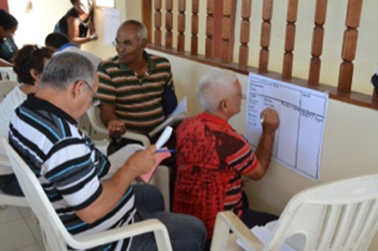
Friday: Pray for Cuba-
- The government continues to pressure the church to give in to non-biblical beliefs to promote.
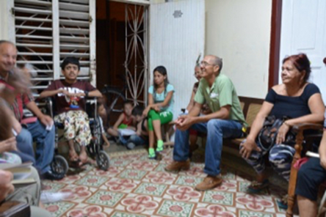
- Hunger was a problem before Covid-19 hit; the needs are only more severe now.
- Continue to use the marriage retreat and Foundations as ways to meet needs and share the Gospel. The country will be more open to the gospel in this time of crisis.

Saturday: Pray for Church Staff-
- Church leaders to find ways to continue to worship in this time of lock-down.
- Church leaders to have the health and energy to reach out to those in need – even now.
- Church members to remember to reach out to neighbors and fellow church members to provide friendship, encouragement, help and love.
- Church members to continue to worship the Lord daily in their hearts and homes.

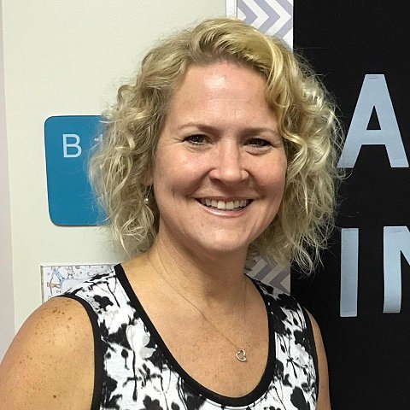

Ken Metcalf, Kristal Turpin, Tim Hopper, Steve Shepard, Kathy Brown, Mike Miller, Todd Vermilyea, Lori Martin, Ryan Wicker, Patty Goodwin, Kellie Stockman, Brent Tucker and countless others working with us….

