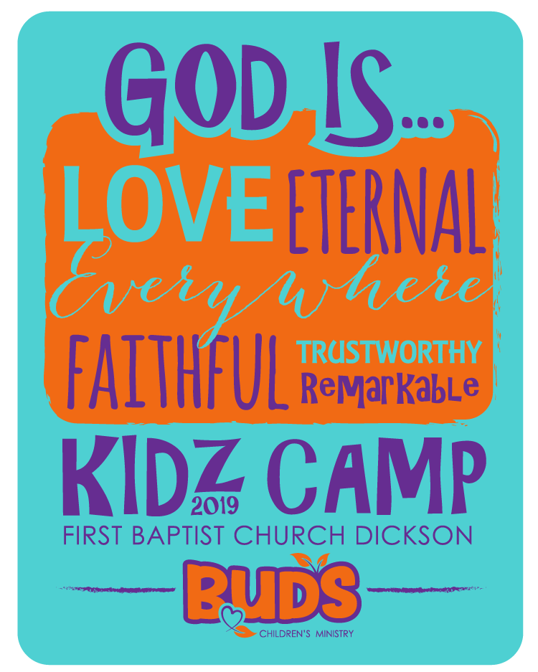
DEAR PARENTS,

FBCD-Kids Ministries invites your rising 2nd – 6th grader(s) to “Bloom” with us at our 2nd annual Kidz Camp located at Montgomery Bell State Park, Group Camp 2. There will be hiking, fishing, sports, crafts, creek play, large group Bible studies and small group Bible studies, and family night. And of course, sleeping in cabins.

Kidz & their family will arrive Monday, July 15th @ 6:00 to set up their beds, enjoy an ice cream bar and participate in family games and worship. After worship, we will tell our families “see you on Wednesday” and then end the evening with small group games and devotions. Tuesday, after rising and shining, we will have several large and small group worship sessions, enjoy some crafts, leave and go fishing, hiking and creek wading. We will end the evening with some games and watermelon. Wednesday the 17th will come too soon, and we will find ourselves packing up all our belongings and anticipating the arrival of our families at 10:30 AM so that we can go home and take a nap.
We would love for your “Blooming” child to join us. Please fill out the form online at http://www.fbcdickson.org/events The cost of this event is $50 and is payable on-line. Don’t forget to add your child’s t-shirt size. Deadline to register is Monday, July 1st.

For more information, call Ken Metcalf at 615-319-8141 or Susan Hasley at 615-406-0529.

