Moses a man who heard from God – Ex. 25
The Tabernacle
Focal Truth: God revealed to Moses the earthly pattern of the tabernacle revealing the glory of heaven & the Lord Jesus Christ
Observations
- God gave to Moses the pattern for the construction of the tabernacle for Israel to meet God on the earth
Ex. 25:8 – 9 – let them construct a sanctuary for Me, that I may dwell among them. According to the pattern of the tabernacle and the pattern of all its furniture, just so you shall construct it
Ex. 26:30 – then you shall erect the tabernacle according to its plan which you have been shown in the mountain
Acts 7:44 – our Fathers had the tabernacle of testimony in the wilderness, just as He who spoke to Moses directed him to make it according to the pattern (type) which he had seen
Pattern = image or likeness
- Construction of the pattern of the tabernacle
- Construction of the pattern of the furniture for the tabernacle
- God commanded Moses to construct the tabernacle to the exact pattern He had revealed to him
Ex. 25:40 – See that you make them after the pattern for them, which was shown to you on the mountain
- The tabernacle is a pattern – image of the realities & glories of heaven
Heb. 8:1 – 2 – now the main point in what has been said is this, we have such a high priest, who has taken His seat at the right hand of the throne of the Majesty in the heavens, a minister in the sanctuary and in the true tabernacle, which the Lord pitched, not man
In the sanctuary = hagios – the place of reverence, sacred place – “the holiest”
In the true tabernacle = tent
Heb. 8:5 – who serve a copy – representation and shadow – image cast by light of the heavenly things, just as Moses was warned by God when he was about to erect the tabernacle, for, See, He says, that you make all things according to the pattern which was shown you on the mountain
- The tabernacle is a pattern – image of the glory of God in Jesus Christ
John 1:14 – the Word became flesh and dwelt – tabernacled, lived temporarily among us, and we saw His glory, glory as of the only begotten from the Father, full of grace and truth
Co. 2:9 – for in Him all the fullness of Deity dwells in bodily form

A glimpse of heaven from earth – the furniture of the tabernacle
- The ark of the Covenant – Ex. 25:10 – 22
Ex. 25:22 – there I will meet with. You and from the above the mercy seat from between the two cherubim which are upon the ark of testimony, I will speak to you about all that I will give you in the commandment for the sons of Israel
- God meets with the High Priest at the ark of the Covenant – the throne of God
- God meets with the High Priest at the mercy seat – place of propitiation – satisfaction, the place of covering sins.
- The mercy seat is sometimes called the footstool of the throne of God
- The angels represent the presence of God – the angels gaze on the act of propitiation by the sprinkling of the blood of sacrifice
The glory of Jesus Christ & heaven in the ark & mercy seat
- Jesus Christ is the propitiation – satisfaction for our sins by his death on the cross 1 John 2: 1—2 – I am writing these things to you so that you may not sin. If anyone sins, we have an Advocate with the Father, Jesus Christ the righteous, and He Himself is the propitiation for our sins, and not for ours only, but also for those of the whole world
1 John 4:10 – in this is love not that we loved God, but that He loved us and sent His Son to be the propitiation for our sins
- The satisfaction of the wrath of God comes through the sacrifice of Jesus Christ
- God accepts the sacrifice of Jesus Christ & forgive us
- The throne of grace is covered with the blood of the lamb of God – Jesus Christ
- The angels are amazed & long to understand the glory of Jesus Christ death on the cross as the payment for our sins
1 Pet. 1:12 – it was revealed to them that they were not serving themselves, but you, in these things which now have been announced to you through those who preached the gospel to you by the Holy Spirit sent from heaven – things into which angels long to look
Rev. 5:11 -12 – then I looked and I heard the voice of many angels around the throne and the living creatures and the elders and the number of them was myriads of myriads and thousands of thousands, saying with a loud voice, worthy is the Lamb that was slain to receive power and riches and wisdom and might and honor and glory and blessing
- The table of Showbread – Ex. 25:23 – 30
Ex. 25:30 – you shall set the bread of the Presence on the table before Me at all times
Lev. 24: 5 -9 – you shall take fine flour and bake twelve cakes with it…you shall set them in two rows, six to a row, on the pure gold table before the Lord… it shall be for Aaron and his sons, and they shall eat it in a holy place, for it is most holy to him from the Lord’s offering by fire, his portion forever
- The table was made on which a meal offering was continuously laid before God
- The showbread consisted of 12 loaves of bread representing the 12 tribes before the Lord and was renewed each Sabbath
- The bread is called “the bread of Face” or “presence” because it was set before the presence of God.
- The priests ate the bread in the Presence of God in the house of God
The glory of Jesus Christ & heaven in the Showbread
- Jesus Christ is the bread of life – he invites us to come to him by faith like eating bread – John 6:53 – 58
- God provides for His people – the bread of life the Lord Jesus Christ
- Believers come to the table of the Lord & eat together in the presence of the Lord remembering His sacrifice for our sins on the cross
- Believers will gather at the marriage supper of the lamb in heaven – forever in the presence of the Lord
- The golden lampstand – Ex. 25:31 -40
Ex. 25:37 – then you shall make its lamps seven in number, and they shall mount its lamps so as to shed light on the space in front of it
- The lampstand provided light inside the tabernacle
The glory of Jesus Christ & heaven in the lampstand
- God began creation by creation of light – Gen 1:3 – God said, let there be light and there was light
- God is light – 1 John 1:5 – God is light and in Him there is no darkness at all
- Jesus Christ is the true light coming into the world – John 1:9 – there was the true light, which coming into the world, enlightens every man
- Heaven is lighted by the presence of God no need for a sun – Rev. 21:23 – and the city has no need of the sun or the moon to shine on it, for the glory of God has illumined it and its lamp is the Lamb
- Believers walk in the Light of God living in the truth of God – 1 John 1:7 – if we walk in the Light as He Himself is in the Light, we have fellowship with one another, and the blood of Jesus His Son cleanses us from all sin
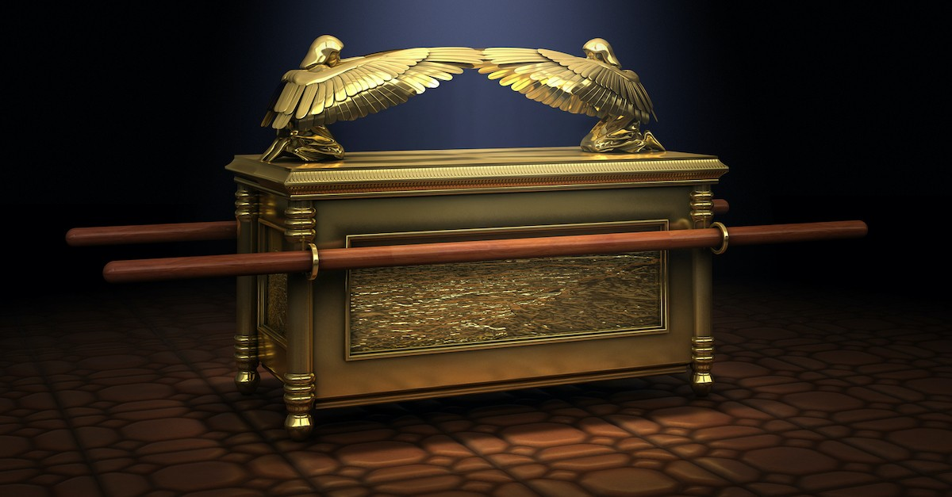
To the praise of the glory of His grace. The Lord is near to the door. Come Lord Jesus!

