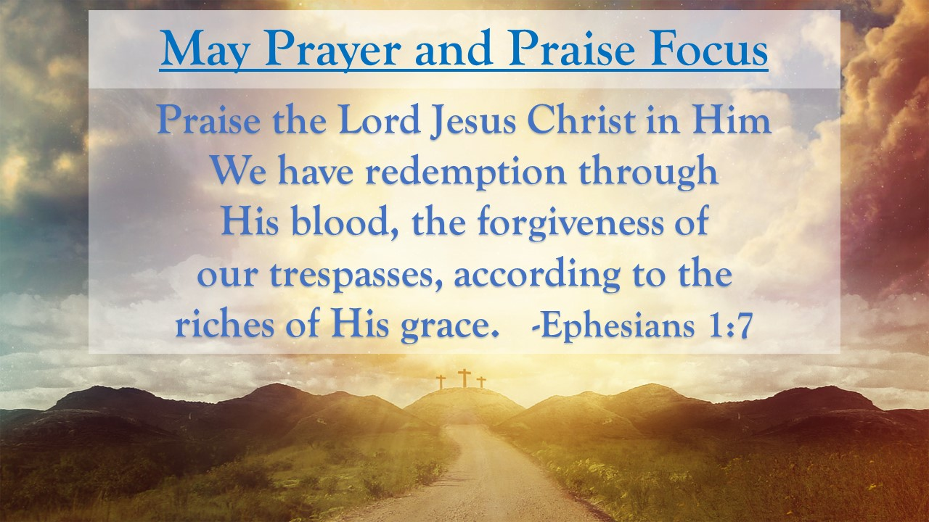
First Baptist News & Info |  |  |  | MAy 3, 2024
Prayer Focus for month:
Ephesians 1:7

Praise Note: |  | Redemption! Can you hear the voice of Jesus claiming your heart, mind & soul? He died on the cross willingly – paid the price and redeemed our lives for His. We owe nothing for this gift of grace, but we should give glory and praise for our deliverance. Lift your voice to celebrate, exalt and glorify the Lord Jesus Christ!

 |  | MAY 3, 2024
Invite a friend, Sign up to help, or join us for the week and let’s have fun learning about God’s rock solid truth in a world of shifting sands.  Attendance/Offerings: April 28, 2024  - Sunday Morning Worship – 518  - Sunday School – 540  - Online Worship – 57  - Tues/Thurs Bible Studies- 36  - Wednesday Program – 342  - Wednesday Online - 32  - Tithes & Offering Budget: $31,733.50  Regular Worship at 9 AM and 10:30 AM in the Sanctuary. The 10:30 AM service will be livestreamed via Facebook and YouTube. Sunday School classes are available for all ages at 8:00 AM (adults only), 9:00 AM (all ages), and 10:30 AM (adults and Preschool only)  Register for Girdiron Men’s Conference: June 14-15 in Huntsville, AL. Cost starts at $200.00. Registration and information is on the men’s bulletin board and the church website. If you have questions please contact Pastor Todd Vermilyea. |  | Upcoming Activities  - May 5th – Senior Graduation Recognition  - May 5th at 11:45 am - White Rose Luncheon  - May 9th – 6 & 7 pm – PreK Graduation Programs  - May 11th – 8 am -10 am – Ladies Fellowship Breakfast  - May 14th – 5-7 pm – PreK/CDC Family Aprreciation  - May 20th – 4 pm – Senior Game Night  - May 23rd – 1 pm - Widow’s Fellowship
Mid-week Activities: Wednesday, May 1st
- Youth Choir – 5:00 pm in the choir room
- Kids JAM - Children’s Choir – 5:15 pm in the B hallway (End of Year Celebration)
- Fellowship Hall: Pastor’s Bible Study – 6:30pm
- DiscipleLife Classes: 6:30pm, C-Hallway, Guest Central, Youth Building
- Children’s Activities: Children’s Activities: 6:30 pm childcare for birth through ages 3, Mission Friends, RA/GA classes (Pastor Ken Metcalf, Children’s Minister)
- Student Activities: 6:30 pm Conference Center (Pastor Tim Hopper, Student Minister)
- Adult Choir: 6:30 pm (Pastor Jeff Clark)

