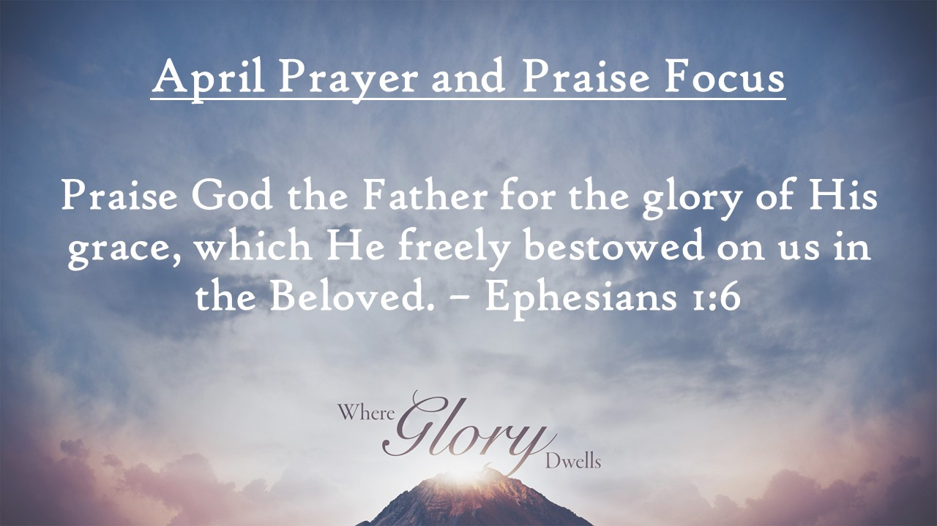
First Baptist News & Info |  |  |  | April 26, 2024
Prayer Focus for month:
Ephesians 1:6

Meditation Moment: |  | What powerful truths are here in this first chapter of Ephesians. God chose us before the foundation of the world, we should be holy and without blame before Him in love. He has made known to us the mystery of His Will and has made us accepted in the Beloved. We are accepted by God, forgiven through the sacrifice of Jesus and redeemed. Now let us praise the Father for these blessings, because we aren’t worthy…we are received by grace.

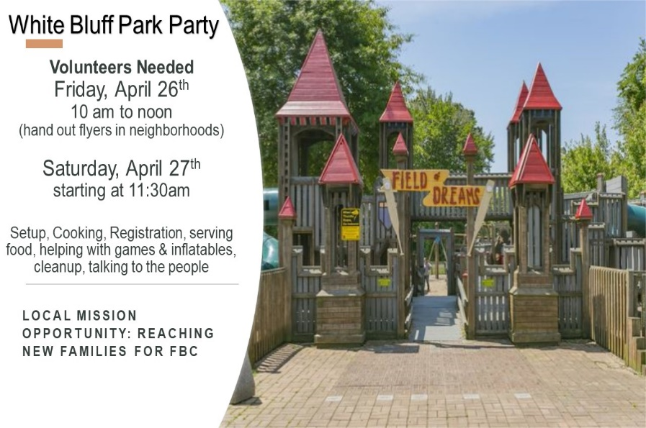
 |  | April 26, 2024
Invite a friend, Sign up to help, or join us for the week and let’s have fun learning about God’s rock solid truth in a world of shifting sands.  Attendance/Offerings: April 21, 2024  - Sunday Morning Worship – 482  - Sunday School – 522  - Online Worship – 58  - Tues/Thurs Bible Studies- 32  - Wednesday Bible Studies – 352  - Tithes & Offering – Budget: $27,706.76 Sacred Trust: $300.00  Regular Worship at 9 AM and 10:30 AM in the Sanctuary. The 10:30 AM service will be livestreamed via Facebook and YouTube. Sunday School classes are available for all ages at 8:00 AM (adults only), 9:00 AM (all ages), and 10:30 AM (adults and Preschool only)  Register for Girdiron Men’s Conference: June 14-15 in Huntsville, AL. Cost starts at $200.00. Registration and information is on the men’s bulletin board and the church website. If you have questions please contact Pastor Todd Vermilyea. |  | Upcoming Activities  - April 27th – 1pm to 3 pm - White Bluff Park Party Outreach (signup on front bulletin board)  - May 1st – 6:30 pm – Kid’s JAM Spring Musical  - May 5th – Senior Graduation Recognition  - May 5th at 11:45 am - White Rose Luncheon  - May 9th – 6 & 7 pm – PreK Graduation Programs  - May 11th – 8 am -10 am – Ladies Fellowship Breakfast
Mid-week Activities: Wednesday, May 1st

- Kids JAM - Children’s Choir Musical at 6:30 pm in the Sanctuary. All Bible studies, groups & classes will meet together and support our “future” adult choir members.
